IMPACT REPORT

Improving and Inspiring the Lives of Others

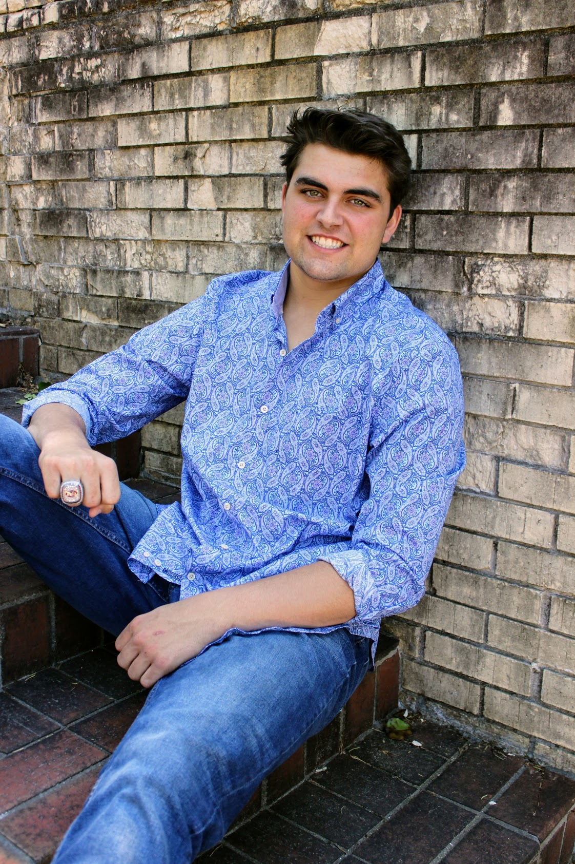

Because of the support of our donors, followers, and partners, we raised over $175,000.00 in the last 3 years towards our mission; improving and inspiring the lives of others.
Your generosity has helped our small charity make a BIG impact in the brain tumor community and in our own community through advocacy, research, and patient support.

We are also honored to have awarded 14 scholarships to young leaders in our community in honor
Of Our Friend, Christopher Miles. THANK YOU!

Check out some of the high lights from 2024
ourfriendchristopher@gmail.com | www.ourfriendchristopher.com | Social: @ourfriendchristopher

ADVOCACY - In 2024, Our Friend Christopher brought our message to congress for the 3rd year in a row with over 300 advocates asking for Brain Cancer Research Funding and legislation that would improve the quality and quantity of life for a brain tumor patient. The top three results of our 2024 congressional meetings were:
- $10-million-dollars allocated for Glioblastoma Research
- OFC Introduced the B.R.A.I.N ACT to the 118th congress.
- 5-point Increase in Federal Brain Cancer funding as it relates to total cancer funding. This is an increase from 3% in 2018 to 8% of total cancer funding in 2024.
- An OFC member was nominated to serve on The Congressionally Directed Medical Research Program for Glioblastoma in 2024/2025. The focus is on “Penetration of the Blood Brain Barrier,” which is the top obstacle to delivering therapeutic drugs to Glioblastoma Brain Tumors.
Why is this advocacy important? Glioblastoma is the deadliest, most treatment resistant and costly of all brain tumors. Life expectancy is 12 months from diagnosis. There are currently NO known causes or cures for Glioblastoma. The Federal Government is the top contributor for cancer research and that is why we ask for more of the federal allocated dollars.
RESEARCH – In 2024, Our Friend Christopher continued to support scientists and organizations who work to eliminate the challenges of Brain Cancer through research focused on early detection, prevention and therapies that support quality of life. Our top highlights in research are:
- OFC provided funding to support the opening of the First Genomic Testing Center in the US.
Why is genomic testing important? Genomic testing will close the gap in finding timely and beneficial trials and therapies to treat the unique bio markers of Glioblastoma.
- OFC helped fund research for Pediatric high-grade glioma (PHGG).
Why is this research important? Pediatric High-Grade Glioma’s are the leading cause of death by disease among children in the United States. Pediatric brain tumor research is critical to understanding therapies that support a cure, while preserving a young developing brain.
- In 2024, The FDA approved three new brain tumor drugs. One of these drugs has been defined as safe for children over the age of 6 months.
SCHOLARSHIPS / PATIENT SUPPORT
- In 2024, Our Friend Christopher awarded 4 college scholarships to young leaders in our community. A total of fourteen scholarships have been awarded to community members in honor of Our Friend, Christopher Miles, since his passing in 2020.
- In 2024, Our Friend Christopher offered financial support to four community members suffering from rare diseases and offered patient support to over one hundred Children at the Aflac Cancer and Blood Disorder Center through funding and comfort gifts.

